Sinquefield Invention Lab- Lake of the Ozarks Scout Reservation
The purpose of the Invention Lab is to promote creativity and teach STEM related subjects. The Invention Lab will be a 6,000 square foot building, with wireless web and wi-fi, with high end equipment available for year round activity. The Lab will be broken into four to five major labs and three non lab areas. In addition, we will have a mobile Invention Lab with major equipment. We will call them Learning Topics. Jeanne Sinquefield developed the Invention Lab (and funded it) while working closely with Inventor Steve Goldstein, and the Great Rivers Council. The Learning topics cover general tools/skills needed for developing Inventions by Invention Scouts.

Learning Topics
- Electronic and Robotic Lab
- Electronic equipment including soldering.
- Raspberry Pi and other similar hardware.
- Arduono programming and other programing languages.
- Robotic equipment and supplies
- 2D and Woodworking Lab
- Epilog Laser System
- Metal Working
- Shopbot or CNC Router
- Corel Draw and other design software
- Woodworking tools
- 3D Lab
- 3D Printers
- Digitizers
- CNC Milling Machine
- SketchUp/CAD and CAM Software
- Print and Design Lab
- Vinyl cutter/ large format printer
- Digital Fabric Printer
- Sewing Machines-embroidery, etc.
- Multimedia
- Photography and multi purpose printer/copier/scanners
- Adobe Software Photoshop, Illustrator, Premier Pro (video editing)
- Leadership
- Business
- Creativity

What are Invention Scouts?
Inventions Scouts will be either part of the Boy Scouts of America Exploring Program or their Venturing Program. The former is school based, and the later includes camping. Invention Scouts include both young women and men aged 14-21. Scouts at 21 can become adult advisors. The following is the general structure of the program.
- Skill Based
- Programming Languages-
- Use of Computer Guided Software Programs-
- Use of computer guided equipment-
- Electronics/Robotics-
- Equipment in Invention Labs

- Teamwork Based
- Leadership skills
- Working as a team.
- Delegating responsibilities.
- Planning of projects.

- Creativity through inventions.
- Creating new inventions ideas.
- Solving problems with new inventions.
- Improving existing products.
- Invention competitions.

- Ethical/Business Knowledge
- Ethical behavior
- Developing Business Plans
- Productions of new inventions
- Marketing/Sales of New Inventions.

- Community Service
- Teaching others to be inventors
- Inventions that benefit others

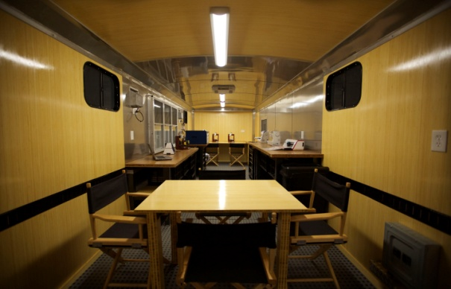
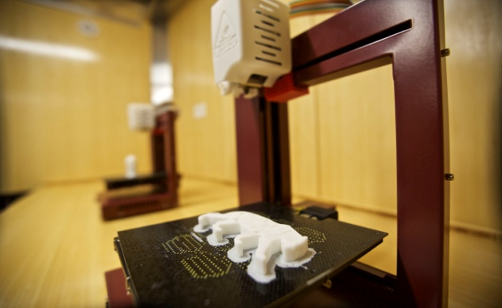
POST OR CREW ORGANIZATION
- Adult Advisor
  - Assistant Advisors (Mentors)

      - Crew President
        - Crew Executive VP
CREW DEPARTMENTS
          - VP of Business
            - Leader ship training
            - Business Plans
            - Sales
            - Mass Production
            - Legal/Intellectual Property
          - VP of Technology
            - Electronics and Robotics
            - Programming
            - Micro-Controllers
          - VP of Facilities
            - 2D Woodworking Lab
            - 3D Lab
            - Shop Equipment & Tools
            - Prototype Manufacturing
          - VP of Marketing
            - Multimedia Lab
            - Marketing
            - Social Media
            - Print and Design Lab

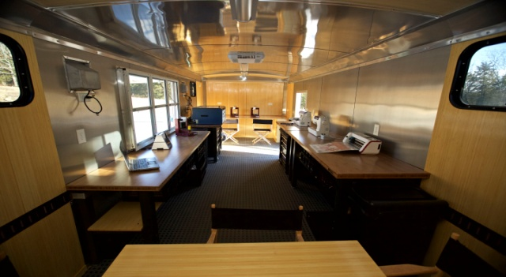
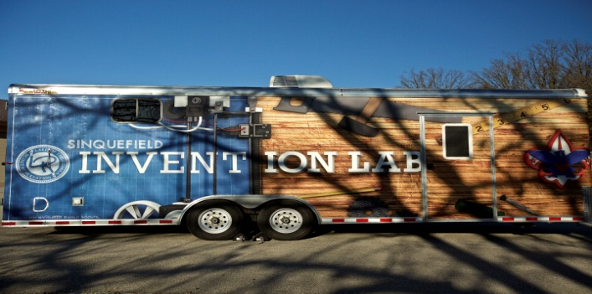
EXPLORER POST OR VENTURING CREW TEAMS
4 to 10 members. Mutiple teams in a Post or Crew.
At least one member specializes in each department.
Annual Goals
New members pass 4 apprenticeship skills, one in each department.
Older members work on Journeyman or Master skills, one in each department.
Team competes in at one Invention Competition.
Team posts video and description about one invention on Crew Webstore.
Team does at least one fundraising using invention skills.
Team uses skills learnt for Community Service project(s).

Ranks/Skill Award/Invention Achievements
Apprentice – Just learning the tools/skill in a department.
Journeyman – Proficient at the tool/skill and is qualified to teach to the Apprentice
Master- Has mastered the tool/skill and is qualified to teach to both Apprentice and Journeyman.
Scouts can earn Skill Awards and Invention Achievements.

Advisors \Experts(Mentors)\Volunteers
Adults leaders must be 21 years or older .
Advisors of a Post or a Crew are responsible for oversight of the Post or Crew. The Crew or Post and their Invention Teams will be Scout run.
Expert(Mentor) offer expertise to teams, and/or give lectures or courses on select skills or tools to Posts or Crews.
Volunteers are adults who help at various times and events when needed.
Invention Scout Leaders will have the opportunity to learn the same skills and tools that Invention Scouts do, and have access to the Invention Lab equipment.
Starting or Joining a Crew
The staff of the Great Rivers Council will work with adults to start a Post or Crew. The Council is broken into seven districts served by district executives. Typically the Post or Crew needs a Board of Director (5 people), a meeting place, and a chartering organization. The adult leaders must be registered with Great Rivers Council, Boy Scout of America.
Once a Crew or Post is started then Invention Scouts and adults can join. All adults will be required to take an online youth protection course.
Each Crew or Post and their Invention Teams will determine their Invention focus. Their focus can change over time. For example, a team could focus on inventions in fashion, or bio-medical inventions etc.
The Invention Lab is located at The Lake of the Ozarks Scout Reservation. The Mobile Invention Lab travels across the Council, and can be requested.

Great Rivers Council, Boy Scouts of America
1203 Fay Street, Columbia, MO 65201 ph. 573-449-2561

Lake of the Ozarks Scout Reservation
525 Camp Hohn Drive, Gravois Mills, MO 65037 ph. 573-374-5761

